Density & Layers of the Earth Vocabulary
Concept | Definition |  | Visual/Explanation/Analogy
Density
Density | The amount of mass of a substance in a given volume. |  | 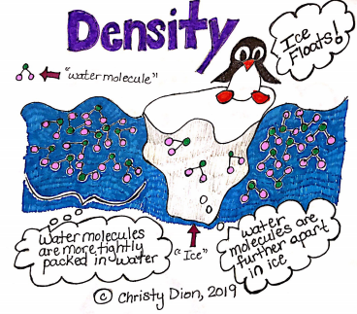
Mass | The amount of matter in an object. |  | 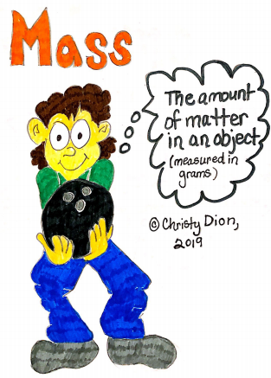
Volume | The amount of space an object takes up. |  | 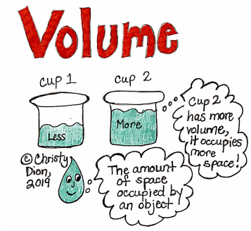
Layers of the Earth
Crust | Earth’s solid rock surface that forms the continents and ocean floor. |  | 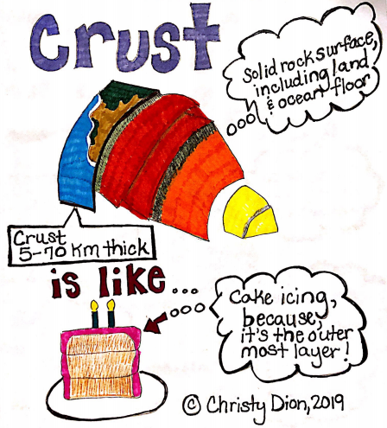
Continental Crust  Forms the continents and consists of rocks such as granite. |  | 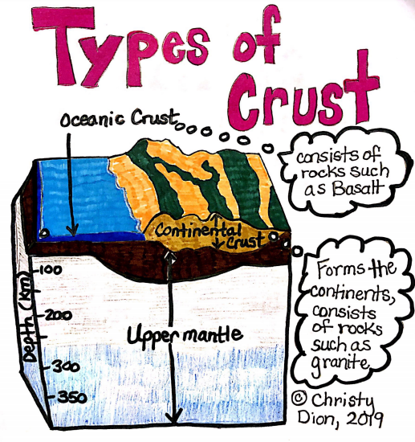
Oceanic Crust
Forms the oceans floor and consists of rocks such as basalt.
Mantle | The layer of hot, solid material between Earth’s crust and core. |  | 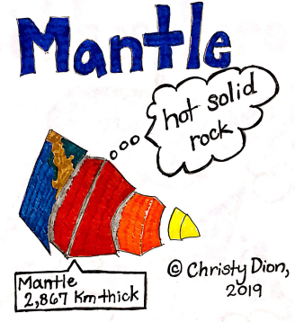
Lithosphere | A rigid layer made up of the uppermost part of the mantle and crust. |  | 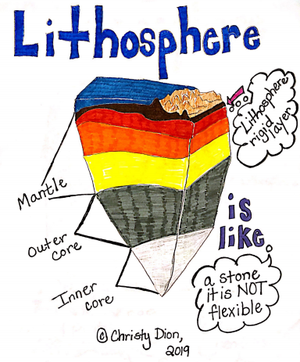
Asthenosphere | The soft layer of the mantle on which the lithosphere floats. This layer is plastic like and flexible or can bend. |  | 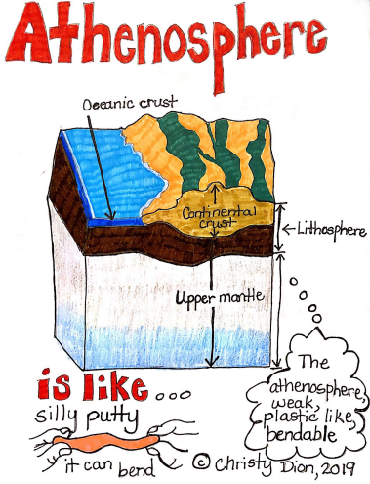
Outer Core | A layer of molten iron and nickel that surrounds the inner core of Earth. |  | 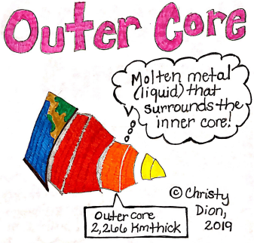
Inner Core | A dense sphere of solid iron and nickel at the center of the Earth. |  | 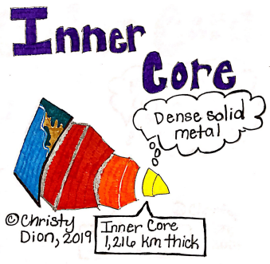
Convection Currents | The movement of a fluid, caused by differences in temperature, that transfers heat from one part of the fluid to another. |  | 